**Code**

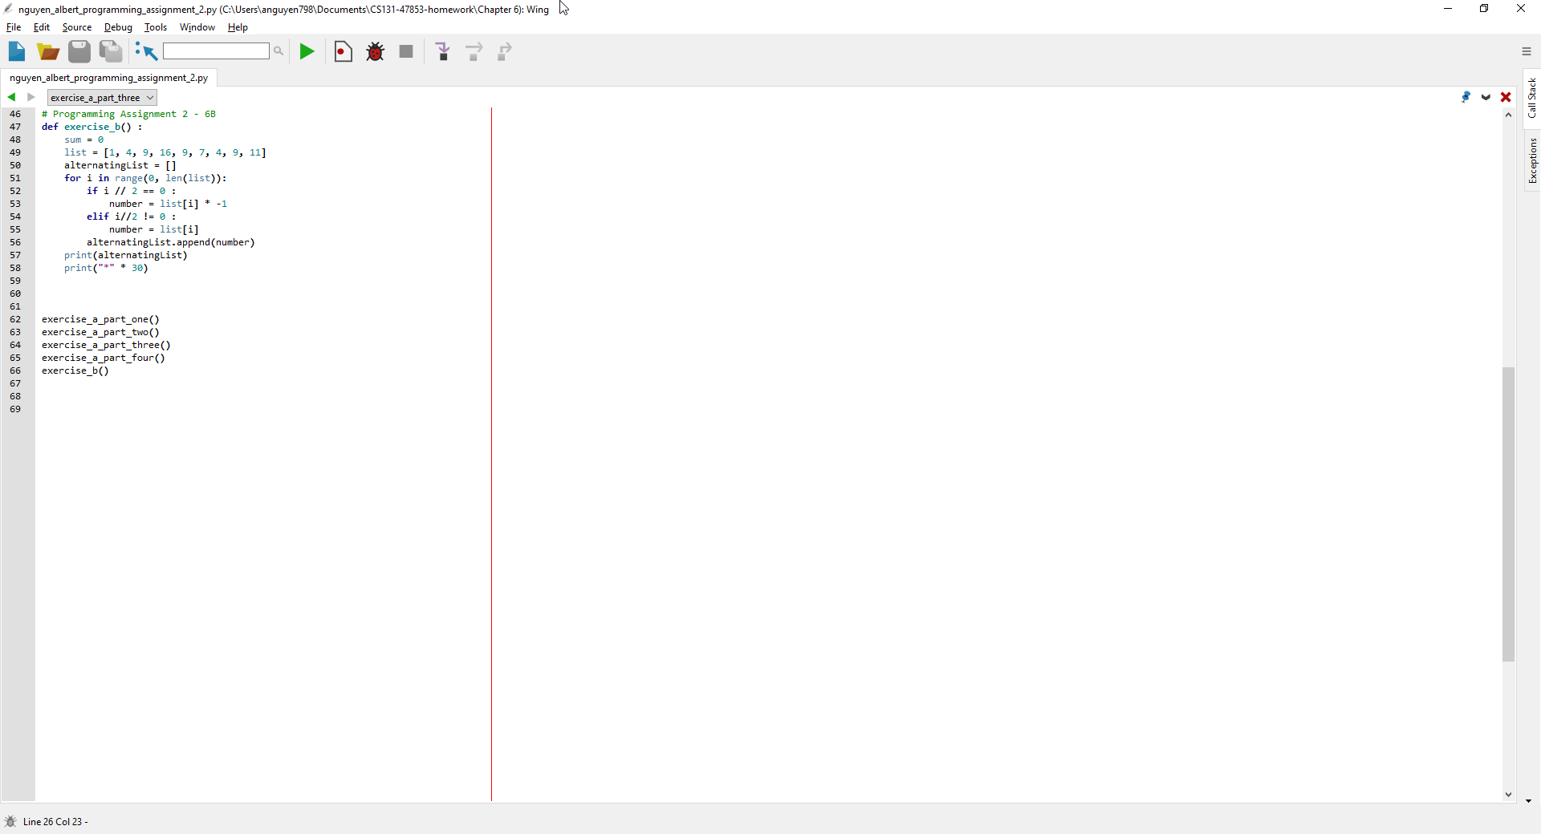

**Output**

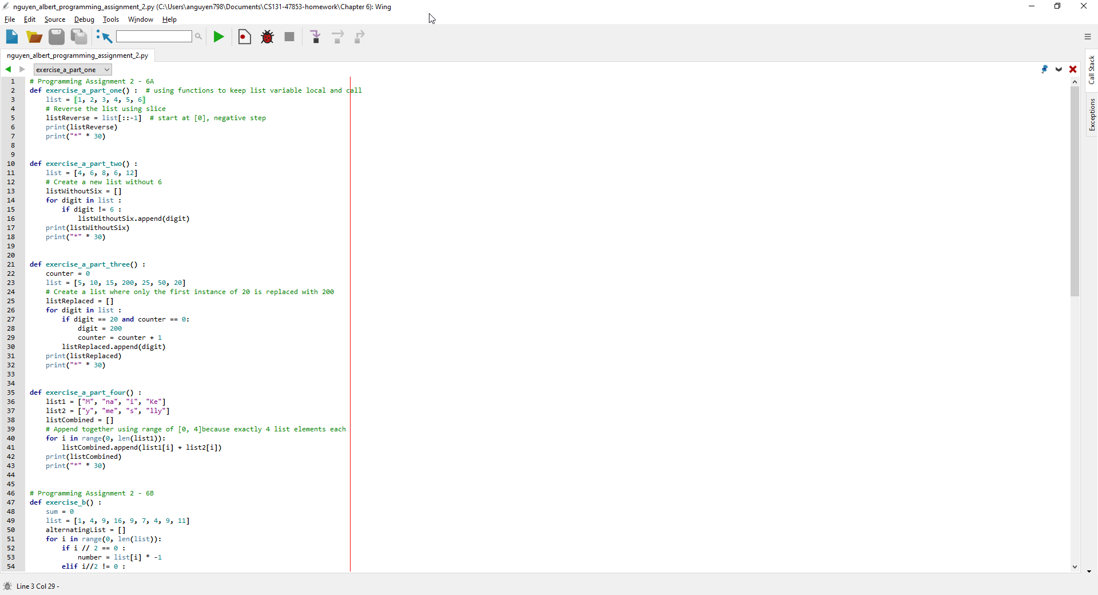

**Code**

# Programming Assignment 2 - 6A

def exercise_a_part_one() : # using functions to keep list variable local and call

list = [1, 2, 3, 4, 5, 6]

# Reverse the list using slice

listReverse = list[::-1] # start at [0], negative step

print(listReverse)

print("*" * 30)

def exercise_a_part_two() :

list = [4, 6, 8, 6, 12]

# Create a new list without 6

listWithoutSix = []

for digit in list :

if digit != 6 :

listWithoutSix.append(digit)

print(listWithoutSix)

print("*" * 30)

def exercise_a_part_three() :

counter = 0

list = [5, 10, 15, 200, 25, 50, 20]

# Create a list where only the first instance of 20 is replaced with 200

listReplaced = []

for digit in list :

if digit == 20 and counter == 0:

digit = 200

counter = counter + 1

listReplaced.append(digit)

print(listReplaced)

print("*" * 30)

def exercise_a_part_four() :

list1 = ["M", "na", "i", "Ke"]

list2 = ["y", "me", "s", "lly"]

listCombined = []

# Append together using range of [0, 4]because exactly 4 list elements each

for i in range(0, len(list1)):

listCombined.append(list1[i] + list2[i])

print(listCombined)

print("*" * 30)

# Programming Assignment 2 - 6B

def exercise_b() :

sum = 0

list = [1, 4, 9, 16, 9, 7, 4, 9, 11]

alternatingList = []

for i in range(0, len(list)):

if i // 2 == 0 :

number = list[i] * -1

elif i//2 != 0 :

number = list[i]

alternatingList.append(number)

print(alternatingList)

print("*" * 30)

exercise_a_part_one()

exercise_a_part_two()

exercise_a_part_three()

exercise_a_part_four()

exercise_b()